A

Project Synopsis

On

**“PC Control and Secure file-sharing using Compression Techniques ”**

SUBMITTED TO THE PUNYASHLOK AHILYADEVI HOLKAR SOLAPUR UNIVERSITY, IN PARTIAL FULFILLMENT OF THE

REQUIREMENTS FOR THE AWARD OF

**BACHELOR OF TECHNOLOGY**

**Submitted by**

**Name of Student PRN Number**

1.Atharv Milind Davale (PRN: 2020032500183191)

2.Abhijeet Balkrishna Surshetwar (PRN 2020032500183392)

3.Rushikesh Rajesh Waghule (PRN:2020032500186525)

4.Amrut Yogesh Virdhe (PRN:2020032500185916)

5.Digvijay Sambhaji Shinde (PRN:2020032500185166)

**Under the guidance of**

PROF. A.M.Dyade



DEPARTMENT OF COMPUTER SCIENCE AND ENGINEERING

**SVERI’s College of Engineering, Pandharpur 2023-2024**

**Index**

|  |  |  |
| --- | --- | --- |
| **Sr.no** | **Topics** | **Page no.** |
| **1.** | **Introduction** | **1** |
| **2.** | **Research Paper** | **2** |
| **3.** | **Literature Survey** | **7** |
| **4.** | **Advantages and Disadvantage** | **8** |
| **5.** | **Problem Statement, Objectives & scope** | **9** |
| **6.** | **Methodology** | **10** |
| **7.** | **Conclusion** | **13** |
| **8.** | **References** | **14** |
| **9.** | **Declaration** | **15** |
|  |  |  |
|  |  |  |
|  |  |  |
|  |  |  |

1. **Introduction**

Nowadays, PC’s, Laptop’s and all other electronic gadgets are inseparable part of our everyday life. Personal computers are not any longer meant for working purpose, but more and more used for entertainment in people’s spare time. This is also applicable to the mobile phones, which have transformed into multifunctional devices with almost same features as computer’s have.

Smartphone’s are common and commercially used device all over the world, user- friendly interface and lots of features such as Wi-Fi, Internet access, Bluetooth, Camera, Video recording etc. add-on to the Android smartphone to be popular all over the world with cheap cost. We propose application which is compatible and useful in both the areas, the aim is to utilize provided hardware features from smartphone devices along with various useful libraries from Android API. As a result, an application combining diﬀerent pointing devices is created.

The connection of a smartphone with the Laptop is established wirelessly via Wi- Fi, for desktop an external modem is used to have a Wi-Fi connection. One of the most widely used mobile OS these days is Android. Android comprise not only operating system but also middleware and key applications. Android Inc was founded by Andy Rubin, Rich Miner, Nick Sears and Chris White at Palo Alto of California, U.S. in2003.Later Android Inc was acquired by Google in2005. After original release there have been number of updates in original version of Android.

There was a Need for a App that Not only Solve the Issue but also Give User a Single Platform for all their sharing Need. An all in one app to solve the issues of the user for file sharing and controlling pc. It uses latest Wifi Hotspot Technology to send and receive the Files with the application, you do not have to worry about the file format you want to transfer as well. many applications only allow you to transfer data of a specific format. We usingcompression algorithm for sharing larger files.

**Research Papers**

In the scope of remote control there are several projects and initiatives designed to allow remote control between devices. Although most of the architectures have the objective of control remotely PCs,

**[1]** For Instance we have one software **Gmote** : This is an Android remote application that is used to control a VideoLan Client (also known as VLC) media player, with basic choices such as play, pause, stop, forward track and backward track.However, this remote application has its limitation in controlling one program. It is separated into 4 parts:

* **GmoteClient:** An android application that is installed on a phone.
* **GmoteServer:** A server application that is installed on a user's computer. It receives commands from the GmoteClient and executes those functions by interacting with different parts of the computer, such as the file system or a media player.
* **GmoteCommon:** Stores files that are common to both the gmote client and server. This includes a set of Serializable objects that get exchanged between two to facilitate communication. Important: Since this code is shared, it must only use language features that are compatible with both the Android SDK and a java SDK

**[2] Remote mouse android application** use a client-server architecture and specific communication protocols.

Client-Server Architecture: 1] Client (Android Device)

2] Server (Computer)

* Remote Control Protocol use **Proprietary** standardized remote control protocol
* Communication between Android client and the computer server typically uses **TCP/IP** protocol.

Commands such as mouse movements and keyboards are encoded and sent from client to server. Server decodes that commands and executes corresponding action

**[3]** Gonzalez Villan project is all about an Android application for Remote Desktop Control. **ADB (Android Debug Bridge)** is configured on the device then it provides service of server for communication with this protocol. Android Debug Bridge is used mostly for communication between targeted PC and Android mobile. The communication between client and server using the RFB protocol consists of Handshake, initialization, and Normal interaction

The ADB protocol can be transported over USB or over [Wi-Fi](https://en.wikipedia.org/wiki/Wi-Fi) through [TCP](https://en.wikipedia.org/wiki/Transmission_Control_Protocol). It uses a [client-server architecture](https://en.wikipedia.org/wiki/Client%E2%80%93server_model). There are two different protocols in use. The first is between the client and the server and the second is between the server and the daemon. The daemon is facilitated by the Android USB framework.

### Client ↔ server protocol

The communication mode between the client and server is a TCP socket. The server listens on a port, to which the client has to send a request. The request contains a 4-byte initial field in ASCII and a payload. The payload starts with the word host, to indicate it should be sent to the server. The server can then reply with OKAY or FAIL to indicate the status, combined with an optional payload and length.

### Server ↔ daemon protocol

The messages sent from the server consist of a 24-byte long header, with the following fields:

* Command
* First argument
* Second argument
* Length of the payload, 0 or higher
* [CRC-32](https://en.wikipedia.org/wiki/CRC-32) of the data payload
* Magic value, calculated through command XOR 0xFFFFFFFF

For ADB USB Debugging is required and Connection is depend upon drivers. The ADB is Command Line Tool which have complexity

**[4]**H.Kawashima-In this paper aim at the adoption of desktop virtualization and developed a web-based interface following the cloud computing concept. In this they implemented a sketch of clientless remote desktop based on Google Web Toolkit framework. The remote desktop can be accessed from any OS platform through any HTML5 compliant browser. They plan to reduce the communication overhead in the cloud .

It Uses :

1] RDP (Remote Desktop Access)-It is windows based protocol and Developed by Microsoft

2] VNC (Virtual Network Computing)-It is an Open source protocol that allows remote control desktop.

**[5]** VNC -: The most popular system designed to perform remote control of devices is Virtual Networking Computing. There are a large number of implementations to this solution including applied to Android software stack. It has an open protocol

VNC System is based on **RFB**(Remote Frame Buffer) which transmits all information The VNC system is compound by a server side and some thin clients that connect remotely to the server and send requests to the server to retrieve updates of the remote controlled device.

The limiting factor of bandwidth is a problem due to the amount of that that is sent, above all because of the latency in the network

**Proposed System**

The existing systems are potentially good system which allows us to remotely connect to the machine and access their respective desktops. But they have some limitations. They are listed below

1. One of the application is based on central server, where client and server are connected to the central server. Here the application area is executed on central server. Because of this, the speed of operation is low and the whole system is depends on central server.

2. Another application is controlling desktop from a android phone. But the system uses RFB protocol which is slow protocol. Because of this working of this application is slow. So because of this drawback we are concentrating on proposed architecture.

The Proposed System is based on JAVA Socket Mechanism

The Java Sockets can be used in every system that has Java Virtual Machine, which uses **TCP/IP** protocol. The Android application will have a Server Socket running and awaiting client requests. On the other hand, clients will have Java client sockets that will open communication with the server and will exchange messages with the server until the connection is closed

The data is transferred through streams. You can read data from input stream and write data from output stream on the other hand

Android device will send the corresponding string according to the different events, the next the server will parse the string and call the corresponding operation

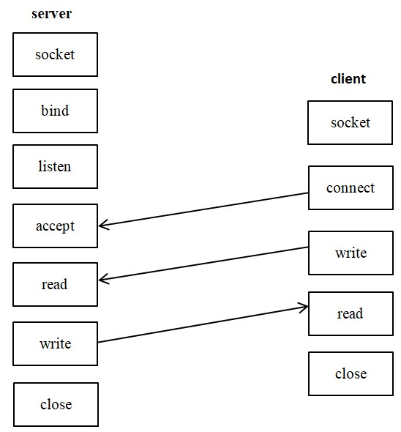

**Secure File Sharing**

In today’s world, there is dominance of Chinese apps in sharing software market. Give User a Single Platform for all their sharing Need. There are other applications in the market as well to name some of them are Most Popular Shareit, Zapya, Xender, ShareMe(Formerly known as Mi Drop). They offer a good File transfer Experience but they lag in on feature or the other. Some have Good UI, some have Great speed while other is good in discovering the nearby Devices. But one thing common among all these applications are annoying ads. Ads are very crucial part for the Revenue but ruining the User Experience is not a Good Strategy.

The problem with previous file sharing techniques is File size limitation. Problems while sharing large files we using advanced compression algorithm for sharing files

**#**We using **ZIP** Compression algorithm it combines two techniques

**1]**Huffman Coding-It encodes symbols and assigns shorter codes it.

**2]**LZ77 Compression-It searches for repeated sequence of byte(phrases) replaces them with reference to previous occurrence.

**#**For security purpose we using

**1]**Advanced Encryption tools

**2]**Use Secure File Transfer Protocols

# Literature Survey

1. In this paper Lingyan Bi et al.proposed a novel method to Design a Android based Remote Control System e with JNI Interface for providing convenience for the user. Michael Spreitzenbarth et al.
2. In this paper proposed analysis based Smartphone Mobile Malware for forensic Analyses. Xinfang Lee, et al..
3. In this paper presented a novel Android based Forensic System. Enck, W et al.
4. In this paper proposed a secure Android Remote controlling mechanism for performing secure transaction form the Remote location. T. Richardson et al.
5. In this paper proposed a novel method of Internet based Android application to demonstrate working of Internet Computing.

The growing popularity and spread of smart phones has changed the design of computer systems as they were known in recent years. Technological developments have enabled the creation of mobile devices with technical features previously only conceived in PC architectures or similar devices.

# Advantages

* 1. **Eliminate need of hardware:** The use of wireless pc control android app eliminate need of carry wireless hardware such as mouse keyboard.
  2. **Accessibility:** You can easily connect app with less efforts and faster setup. No need to pair and connect device to pc and laptop every time.
  3. **Real Time performance:** The our app is using wifi based communication that makes low latency and almost 0 latency to perform actions which provides smoother experience to user.
  4. **Integration with Existing System:** The project can be integrated with existing system no need to setup new hardware or systems.
  5. **User Friendly Interface:** The development of an intuitive user interface ensures that the system is accessible and easy to use for individuals.

# Disadvantage

1. **Battery Consumption:** Running a remote mouse control app on your Android device can consume more battery compared to regular usage. Constantly transmitting touch gestures and maintaining a network connection can drain your device's battery more quickly.
2. **Sensitivity Adjustments:** Adjusting the sensitivity and responsiveness of the virtual mouse might be more limited compared to the fine-tuning options available with dedicated computer mice.3. Problem Statement

# Problem statement

To create android app that establish connection between laptop,computer and android device using wifi and use android smartphones touchpad as mouse and phone as wireless keyboard and sharing large files from android to desktop with compression techniques

# Objectives and Scope

1. Touch-screen mouse control with two onscreen mouse buttons.
2. Use in either portrait or landscape mode.
3. Works with any Wi-Fi network
4. Keyboard typing capability.
5. Operating computer functionality and handling and modification capability.
6. Support any Android operating system version.
7. Compatible with Mac, Windows and Linux operating systems.
8. Voice typing mechanism, on voice commands all the typing is done in desktop/laptop.
9. It can be used for showing live coding demo.
10. Share files wirelessly from mobile device to pc .

# Methodology

Proposed system can be modelled in two parts server side application (Desktops/Laptops) developed using Java programming language and Client side application (Android phone) which is to be developed in android sdk. To establish connection between both the devices wirelessly Wi-Fi connection technology is used, in which information and commands are transfer in the form of packets, connection is established using IP address of Desktop/Laptops network interface card (NIC)

Android phone and Laptop/PC is interacting with each other via Wi-Fi, the ﬂow of information is exchanged between both the devices, in which actions and commands are translated on both the side and information is transferred in the form of bundles (Packets).

Mobile client application is required to install on Android phone.

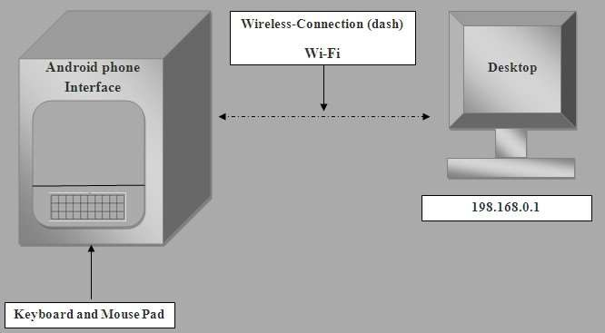

# Creating Server

It will automatically search for a server uses IP address to connect your Android phone to your computer or Laptop or Desktop. The devices must be connected to the same Wireless network. Once the devices are connected, you can open the file browser from your Android phone and start controlling from mobile. For more controls, you need to bring up the virtual keyboard by tapping on the keyboard icon. Pushing a button on a remote control sets in motion a series of events that causes the controlled device to carry out a command

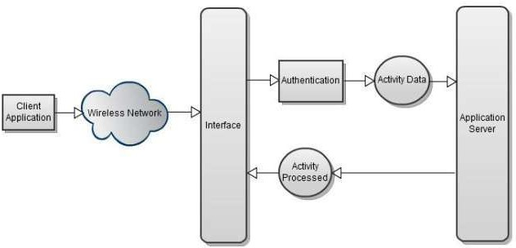

Server application ﬂow diagram

# Android application

When the remote control is run, and it follows the path shown on the figure below. After application starts, the embedded java application server is runs in parallel. Sound notification is implemented in the proposed application so as to let users being aware that their IP address. so it has been validated and the user can proceed with the application

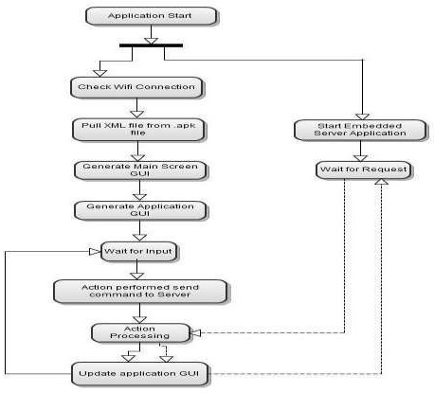

# Conclusion

This project explores the possibility of controlling the computer remotely using an Android phone device. The proposed prototype is able to control a lot of operations a normal computer keyboard and mouse would perform. It practically turns a mobile phone into a wireless keyboard and mouse using a wireless network via a portable mobile device running under an Android Platform Operating System. It helps mobile phone users on facilitating their work in study life, home life or working life, where the use of the prototype helps in easing the device control. It is proven that this project would relieve a pain in the neck and also the normal back ache due to constantly sitting at a particular place. With the help of this prototype, these stressful moments will be minimized as users will be having a very relaxed position as intended. This is a convenient application for simple operations and for manipulating such computer without the keyboard and mouse been connected.

# References:

1. Lingyan Bi, Weining Wang, Haobin Zhong, Wenxuan Liu, "Design and Application of Remote Control System Using Mobile Phone with JNI Interface", The 2008 International Conference of Embedded Software and Systems Symposia (ICESS2008), pp.416-419.2008
2. Michael Spreitzenbarth, "Tools and processes for Forensic Analyses of smartphones and Mobile Malware", 6. GI FG SIDAR Graduierten (2011)https://[www.irjet.net/archives/V7/i5/IRJET-V7I5915.pdf](http://www.irjet.net/archives/V7/i5/IRJET-V7I5915.pdf)
3. Xinfang Lee, Chunghuang Yang, Shihjen Chen, Jainshing Wu, "Design and Implementation of Forensic System in Android Smart Phone", the 5th Joint Workshop on Information Security, 2009
4. Enck, W., Ongtang, M., McDaniel, P., "Understanding Android Security", Security & Privacy, IEEE, Jan.-Feb. 2009, Volume 7, Issue 1, pp.50-57 [5]T. Richardson, Q. Staford-Fraser, K. Wood and A. Hooper, \Virtual networking computing", Internet Computing, Vol. 2, No. 1, pp.33-38, 1998
5. [www.w3school.com](http://www.w3school.com/)
6. https://chat.openai.com/
7. [www.geeksforgeeks.com](http://www.geeksforgeeks.com/)

# Declaration

We the undersigned have submitted the Synopsis report for the proposed Project work entitled “**Pc Control and Secure File sharing using Compression Technique”.** We declare that we have submitted the Synopsis report after through Study& it is not copied from any other source.

Name of Student Sign of Student 1.Atharv Milind Davale

* 1. Abhijeet Balkrishna Surshetwar
  2. Rushikesh Rajesh Waghule
  3. Amrut Yogesh Virdhe _
  4. Digvijay Sambhaji Shinde

**Project Accepted & Approved by:** Prof A.M.Dyade

## Date:

**Place:** Pandharpur

## Name & Sign of Name & Sign of Name & Sign

**Project Guide H.O.D Principal**